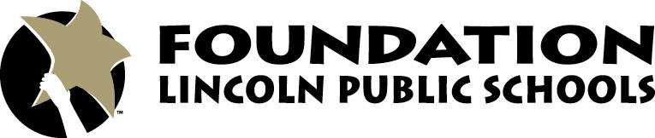

5901 O Street
Lincoln, NE 68510
(402)436-1612

News Release

FOR IMMEDIATE RELEASE FOR MORE INFORMATION:
June 5, 2015 Wendy Van
President
(402) 436-1612
wendy.van@lps.com

Holmes Named Director of Philanthropy at the Foundation for LPS

LINCOLN, Neb. – The Foundation for Lincoln Public Schools is pleased to introduce Kristin Holmes as the Director of Philanthropy. Holmes brings extensive experience working in a non-profit setting, stewarding relationships, developing opportunities, and building awareness for missions which support the greater good. She will work with our generous donors to ensure that students' lives are being impacted by their gifts, now and for years to come.
As a fourth generation Lincolnite, mother of four LPS students, a former educator, and the owner of a small Lincoln business, Holmes is invested in our community and the success of the students who will likely be our future leaders.
“It’s a perfect fit,” Holmes noted. “Working with the generous donors at the Foundation to ensure that we are good stewards of their gifts, and that students’ lives are being touched through those very gifts is meaningful to me. It’s important,” Holmes went on to say. “My mother, grandmother, and aunts were educators too. I share their passion for creating opportunities for students and look forward to my work at the Foundation.”

###

